

**Final Group Project**

Presented to

Professor Animesh Animesh

By

Barabasz, Michelle – 261152119

Pelletier, Tomy - 261165447

Wang, Jiaxuan - 261144434

El-Ghoubaira, Vincent - 260761240

INSY 661 - Section 075

McGill University - Desautels Faculty of Management

Thursday August 24th 2023

**Project Scope**

The project revolves around creating a comprehensive database for a laptop-selling website, similar to newegg.ca. The website targets a diverse range of customers, from individuals to small businesses, seeking customizable laptop solutions. Laptops are known for their extensive customization options, making it essential for customers to have a platform that facilitates easy comparison based on their unique requirements.

The primary objective of this project is to establish a robust database system that supports the laptop sales website's functionalities and services. The database will encompass a wealth of laptop specifications, enabling customers to make informed purchasing decisions. The user base includes both individual consumers and small business entities. Given the highly customizable nature of laptops, the platform will empower users to filter and sort options based on a plethora of criteria, such as GPU, CPU, price range, screen type, brand, RAM, dimensions, model and production year.

The website will not only cater to customers but also accommodate business-driven aspects. It will provide insights into discounts available throughout the year, such as clearance sales, special events like back-to-school and Black Friday, as well as bulk purchase discounts.

The mission of the project is to furnish customers with laptops that align perfectly with their technological needs and preferences, all at competitive prices. The platform will serve as a one-stop-shop where customers can explore a wide array of laptop options, configure their desired specifications, and receive personalized recommendations. Furthermore, the database will maintain records of customer interactions, including order histories, and establish a seamless purchasing experience.

We also want our database to allow the management of our organization, NouvelOeuf, to gain insights upon stock management and customer preferences.

**Overview of the business scenario**

Newegg.ca is an online retail platform specializing in electronics, particularly computer hardware and consumer electronics, offering a wide range of products and services to tech-savvy customers in Canada. Here’s a screenshot of the webpage home screen:

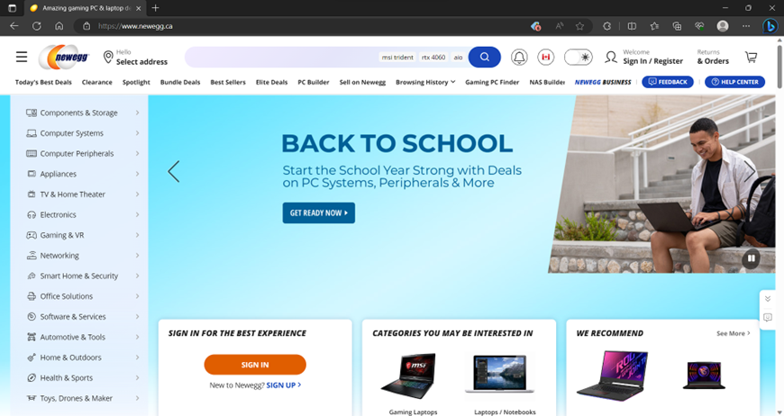

In the context of your project, the laptop section of Newegg.ca's website serves as a primary reference point for designing the database. In the context of the project, the laptop section of Newegg.ca's website serves as a primary reference point for designing the database. The provided screenshots illustrate the essential user interface elements and features that will be incorporated into the project. By examining the laptop page, it's evident that the website allows users to easily search for laptops and apply filters based on various laptop specifications, such as GPU, CPU, price, and production year.

These screenshots serve as a tangible representation of the features and functionalities we aim to implement in the project:

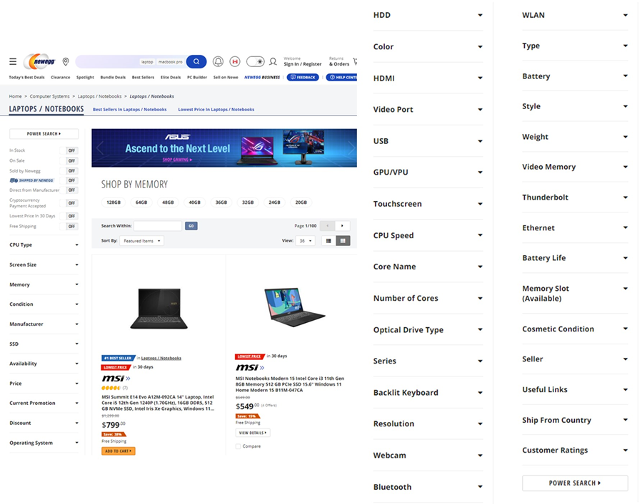

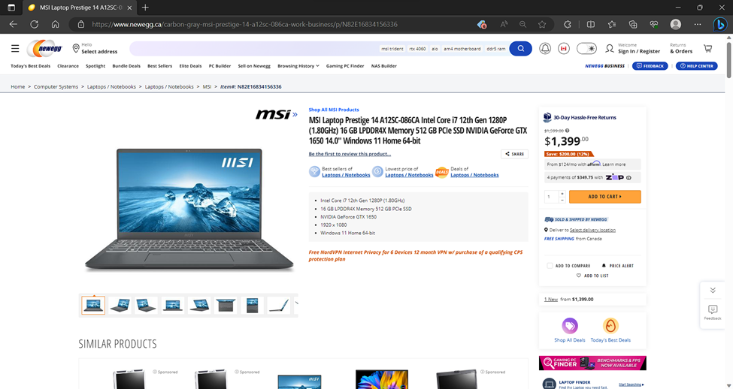

Business Rules:

* GPU and CPU models are assumed to be unique within a given year.
* A brand must offer at least one GPU, CPU, Memory or laptop model each to be included in the database.
* Laptop models influence available screen options.
* Every laptop must be equipped with a CPU and memory.
* An order must include at least one laptop (quantity > 0).
* Customers can only have one active shipping address.
* A customer becomes official after placing their first order.
* The screen options available for a laptop model are influenced by the model itself.
* A laptop model number is unique per brand (e.g., Dell XPS 15 vs HP XPS 15)
* To qualify for free shipping, the order subtotal must exceed the minimum amount set by the business. This minimum can vary by promotion.

By adhering to these business rules, the project aims to create a comprehensive and functional database that facilitates smooth interactions between customers and the laptop-selling platform. This approach ensures accuracy, consistency, and reliability in serving the needs of both users and the business

**Mission Statement**

NouvelOeuf wants to constantly be studying its processes and its customers to keep on improving to deliver products that fits all customers’ needs in the most efficient way possible.

**Mission Objectives**

1. Continuous Process Analysis: Regularly analyze and evaluate internal processes, workflows, and operational procedures to identify areas for improvement and efficiency enhancement.

2. Customer Research and Understanding: Conduct comprehensive research to understand customer preferences, behavior, and evolving needs to tailor products that align with their requirements.

3. Product Customization: Develop a flexible product development framework that allows for customization and personalization to cater to diverse customer segments and their unique preferences.

4. Efficiency Maximization: Identify bottlenecks and inefficiencies within the production and delivery processes and work towards streamlining operations to reduce costs and minimize waste.

5. Data-Driven Decision Making: Utilize data analytics and metrics to make informed decisions regarding product enhancements, customer satisfaction initiatives, and operational improvements.

6. Market Analysis: Regularly monitor market trends, competitor activities, and industry developments to identify new opportunities and potential threats, enabling the company to stay ahead of the curve.

7. Collaborative Partnerships: Foster strategic partnerships with suppliers, distributors, and other stakeholders to create a network that supports efficient production, distribution, and customer satisfaction.

8. Global Expansion: Explore opportunities for expanding the company's reach to new markets and customer segments while maintaining a consistent focus on delivering products that fulfill customer needs efficiently.

9. Measurable Progress: Define clear key performance indicators (KPIs) to track progress toward mission objectives, enabling the organization to measure its success and make data-driven adjustments as needed.

**ERD**

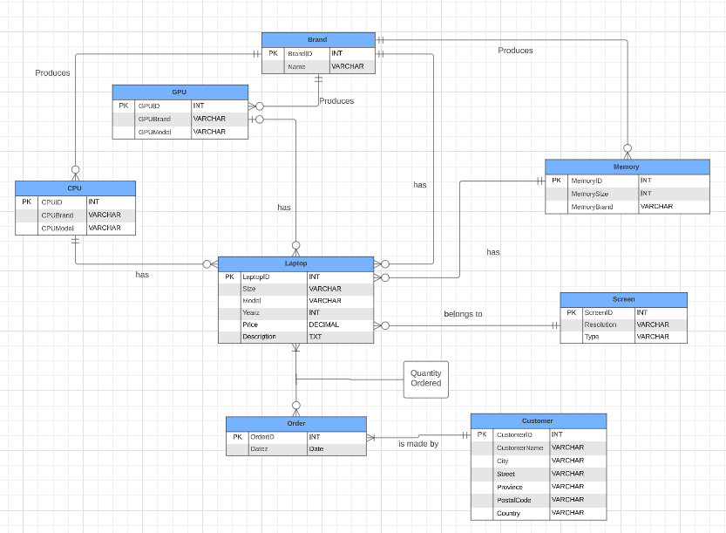

**Appendix A**

**DATA DICTIONARIES**

Data Dictionary 1 - Description of Entities

|  |  |  |  |
| --- | --- | --- | --- |
| **Entity Name** | **Description** | **Aliases** | **Occurrence** |
| Laptop | Contains information about various laptops such as size and price. | Laptop | One laptop must have one brand and a laptop can choose many kinds of CPU, GPU or not. A laptop must have a screen and the same laptop can appear in many orders or not. |
| Memory | Store information about different types of computer memory components, such as memory size and memory brand. | Memory, Storage | A memory must be applied in a laptop. |
| Brand | Contains details about various brands of electronic products available on the website. | Brand | A brand can choose to produce many laptops, GPU,CPU or not, and a brand must have at least one model. |
| GPU | Contains specifications and details about (GPUs) used in computers, such as the brand and the year. | GPU | The same kind of GPU can be installed on many laptops and a GPU can also not be applied on any laptops. |
| CPU | Stores information about CPU used in computers, such as such as the brand and the year. | CPU | The same kind of CPU can be installed on many laptops and a CPU can also not be applied on any laptops. |
| Screen | Contains specifications and details about display screens used in laptops, including resolution and type. | Screen, Monitor | A model of screen can be used on many models of computers, and it is also possible that a model of screen is not used in any computer. |
| Order | Holds information about customer orders placed on the website | Order, Purchase | An order may contain one or more laptops and an order can only correspond to one customer. |
| Customer | Contains details about registered customers who have already placed at least one order on the website. | Customer, User | A customer can place one or more orders. |

Data Dictionary 2 - Description of Attributes

|  |  |  |  |  |  |  |  |
| --- | --- | --- | --- | --- | --- | --- | --- |
| **Entity Name** | **Attributes** | **Description** | **Data Type** | **Nulls** | **Muli-valued** | **Derived** | **Default** |
| Laptop | LaptopID | Unique ID for each laptop | Small integer | No | No | No | None |
|  | Size | Dimensions of laptop | 20 variables chars | No | No | No | None |
|  | Price | Price of laptop | Decimal | No | No | No | None |
|  | Description | A brief description of the laptop | Text | Yes | No | No | None |
|  | Model | Laptop model unique ID | 30 variable chars | No | No | No | None |
|  | Yearz | Year that the model was created | Small integer | No | No | No | None |
| Memory | MemoryID | Unique ID for each laptop memory | Small integer | No | No | No | None |
|  | MemorySize | Amount of memory a laptop has | Small integer | No | No | No | None |
|  | MemoryBrand | Name of memory brand | 20 variable chars | No | No | No | None |
| Brand | BrandID | Unique ID for each laptop brand | Small integer | No | No | No | None |
|  | Name | Name of laptop brand | 20 variable chars | No | No | No | None |
| GPU | GPUID | Unique ID for each laptop GPU | Small integer | No | No | No | None |
|  | GPUBrand | Name of GPU brand | 20 variable chars | No | No | No | None |
|  | GPUModel | Name of the GPU model | 50 variable chars | No | No | No | None |
| CPU | CPUID | Unique ID for each laptop CPU | Small integer | No | No | No | None |
|  | CPUBrand | Name of CPU brand | 20 variable chars | No | No | No | None |
|  | CPUModel | Name of the CPU model | 50 variable chars | No | No | No | None |
| Screen | ScreenID | Unique ID for each laptop screen | Small integer | No | No | No | None |
|  | Resolution | Number of pixels the screen can display | 20 variable chars | No | No | No | None |
|  | Type | Technology used in constructing the screen | 50 variable chars | No | No | No | None |
| Order | OrderID | Unique ID for each order | Small integer | No | No | No | None |
|  | Datez | Date the order was made (day- month-year) | Date | No | No | No | None |
| Customer | CustomerID | Unique ID for each customer who has placed an order | Small integer | No | No | No | None |
|  | CustomerName | The name of the customer | 20 variable chars | No | No | No | None |
|  | City | The city of the customer delivery address | 20 variable chars | No | No | No | None |
|  | Street | The street of the customer delivery address | 20 variable chars | No | No | No | None |
|  | Province | The province of the customer | 20 variable chars | No | No | No | None |
|  | PostalCode | The postal code of the address | 7 Variable chars | No | No | No | None |
|  | Country | The country of the customer | 20 Variable chars | No | No | No | None |

**Appendix B**  
**RELATIONAL SCHEMA**

Laptop (LaptopID, Size, Model, Year, Price, Description, BrandID, GPUID, CPUID, MemoryID, ScreenID)

Primary Key: LaptopID

Foreign Key: BrandID References Brand(BrandID)

Foreign Key: GPUID References GPU(GPUID)

Foreign Key: CPUID References CPU(CPUID)

Foreign Key: MemoryID References Memory(MemoryID)

Foreign Key: ScreenID References Screen(ScreenID)

OrderQuantity (LaptopID, OrderID, Quantity)

Primary Key: LaptopID, OrderID

Foreign Key: LaptopID References Laptop(LaptopID)

Foreign Key: OrderID References Order(OrderID)

Order (OrderID, Date, CustomerID)

Primary Key: OrderID

Foreign Key: CustomerID References Customer(CustomerID)

Customer (CustomerID, Name, City, Street, Province, PostalCode, Country)

Primary Key: CustomerID

Brand (BrandID, Name)

Primary Key: BrandID

Screen (ScreenID, Resolution, Type)

Primary Key: ScreenID

GPU (GPUID, GPUBrand, GPUModel)

Primary Key: GPUID

Foreign Key: GPUBrand References Brand(BrandID)

CPU (CPUID, CPUBrand, CPUModel)

Primary Key: CPUID

Foreign Key: CPUBrand References Brand(BrandID)

Memory (MemoryID, MemorySize, MemoryBrand)

Primary Key: MemoryID

Foreign Key: MemoryBrand References Brand(BrandID)

**APPENDIX C**  
Screenshot of query outputs

|  |  |
| --- | --- |
| Number | Description & Objectives |
| 1 | Description of query: Top 5 sellers in terms of units.  Objective of query: This query assists in understanding customer preferences, and allocating resources effectively to maximize profitability. It also helps the company prioritize production and marketing efforts towards these top-performing laptop models. |
|  | |
| 2 | Description of query: Most popular brand.  Objective of query: The company can use this information to strengthen partnerships with popular brands and negotiate better deals. It also helps in understanding which brands resonate the most with customers, guiding decisions related to brand positioning, and branding strategies. |
|  | |
| 3 | Description of query: Top 5 Country/Provinces with the most sales in terms of Revenue  Objective of query: Helps to understand where most sales happen and orient marketing efforts. In this case, Quebec sales are way above other provinces sales. |
|  | |
| 4 | Description of query: Learning about the most popular GPU and CPU combination  Objective of query: To understand what the most popular GPU and CPU combination are will help understand what type of machine the customer is looking for, regardless of the brand. |
|  | |
| 5 | Description of query: Find the 5 cheapest laptops with the highest GPUs.  Objective of query: This query could be useful for budget-conscious consumers or professionals who are seeking laptops that offer a balance between affordability and strong GPU capabilities, such as for gaming, video editing, or other graphics-intensive tasks. It aims to provide options that prioritize both cost-effectiveness and GPU performance. |
|  | |
| 6 | Description of query: Find all laptops with GPU brand AMD.  Objective of query: This query could be valuable for individuals or organizations looking for laptops specifically with AMD GPUs for purposes such as graphics-intensive tasks, gaming, or compatibility with certain software applications that are optimized for Intel graphics technology. |
|  | |
| 7 | Description of query: Find laptop models and prices within a specified price range.  Objective of query: This query can enhance the user’s experience by helping them quickly locate laptops that match their budget constraints. |
|  | |
| 8 | Description of query: Find the top customer who has made the most purchases and also provide information about their most purchased laptop.  Objective of query: This query can help the company in recognizing high-value customers, understanding their preferences, and establishing a personalized customer experience. It could also be used for loyalty programs, targeted marketing, and improving customer retention strategies by offering products that align with the customer's preferences and purchasing behavior. |
|  | |
| 9 | Description of query: Find the average price of laptops for each screen type.  Objective of query: This query can help in understanding pricing patterns and in optimizing pricing strategies for various laptop models. It provides insights into how different screen types impact the average price, allowing businesses to make informed decisions about product offerings and pricing adjustments. |
|  | |
| 10 | Description of query: Find the total quantity of each laptop model ordered.  Objective of query: This query is useful for assessing the popularity and demand for different laptop models, identifying trends, optimizing inventory management, and making informed decisions about production and distribution strategies. |
|  | |
| 11 | Description of query: Find the top 5 laptop brands based on the total revenue generated from their laptop sales.  Objective of query: This query can identify the most financially successful laptop brands in terms of revenue, which can provide insights into market dominance, customer preferences, and brand performance. This information could be used for strategic planning, partnerships, investment decisions, and competitive analysis within the laptop industry. |
|  | |
| 12 | Description of query: Find the laptops that have been ordered the most, along with the total quantity ordered for each laptop model.  Objective of query: This query can help in understanding the popularity and demand for different laptop models, which can be valuable for business decisions such as restocking, marketing strategies, and inventory management. |
|  | |
| 13 | Description of query: Laptops with GPU and CPU from different brands.  Objective of query: This query helps highlight laptops that stand out in terms of customization and could attract a specific customer segment seeking variety. |
|  | |
| 14 | Description of query: Laptop with the highest total sales in each brand.  Objective of query: This query helps optimize product strategies and focus on popular brands and models. The company can allocate resources, marketing efforts, and inventory management to capitalize on successful models. |
|  | |
| 15 | Description of query: Customers based on their locations, including city, province, and country.  Objective of query: By understanding customer locations, the company can optimize its marketing campaigns. It can target regions with high customer concentrations for localized promotions, events, or partnerships. Additionally, regions with low customer concentrations can be targeted for expansion efforts to increase brand awareness and customer acquisition. |
|  | |
| 16 | Description of query: Laptops with the Highest Number of Orders in the Year with the Lowest Total Sales.  Objective of query: The company gains insights into resilient and sought-after products. This information can guide promotional efforts, discounts, or marketing campaigns to boost sales during tough periods. |
|  | |
| 17 | Description of query: Number of laptops sold each year.  Objective of query: This query helps the company analyze sales trends, demand fluctuations and market growth, aiming in resource allocation and production planning. |
|  | |
| 18 | Description of query: Orders with quantity higher than the average order quantity.  Objective of query: It allows the company to segment high-value customers for targeted marketing. It also enables the design of loyalty programs or incentives to encourage repeat purchases from these valuable customers. |
|  | |
| 19 | Description of query: Laptops with price above average and orders below average.  Objective of query: This query enables the company to adjust pricing strategies, improve product features, or create targeted marketing campaigns to increase the visibility and desirability of these laptops |
|  | |
| 20 | Description of query: Retrieve the laptops with their respective brands and customer names for orders placed in 2022, along with the total quantity of each laptop ordered.  Objective of query: This query assists in evaluating the success of marketing campaigns, understanding customer preferences for that year, and planning for future inventory needs. |
|  | |